Accessing Mail Online in Office 365

Getting Started
Go to www.office.com in your web browser and click on Sign In.

Users will be prompted to sign in using their full Financial Affairs email address and password.

Once signed in, users will see the main Office 365 dashboard which will look similar to the image below. Users will likely see less application tiles available on their dashboards.
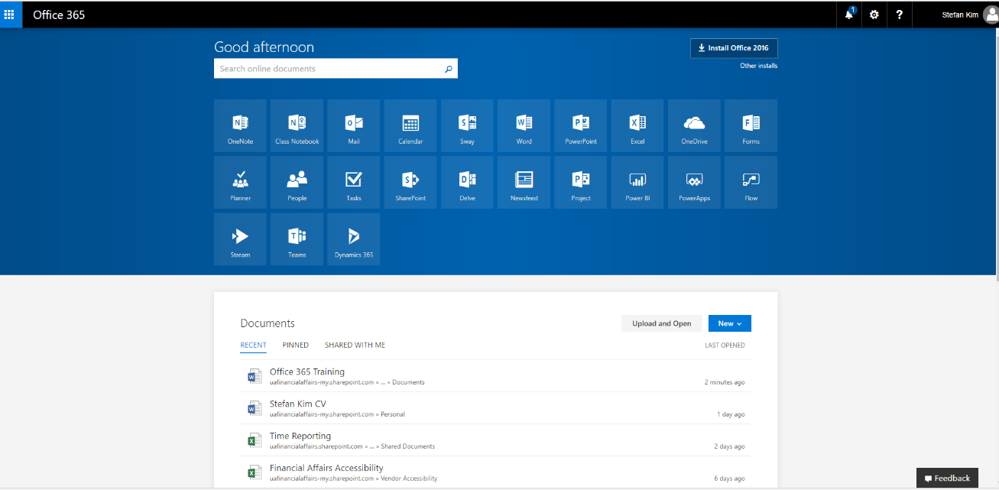

Users should click on the Mail icon tile (highlighted in blue below) on the main Office 365 dashboard to open the application.
Users can also access the Mail application by using the Menu option available throughout the Office 365 dashboard. To open the Office 365 dashboard menu, click on the tiled icon on the upper left corner of the page.

